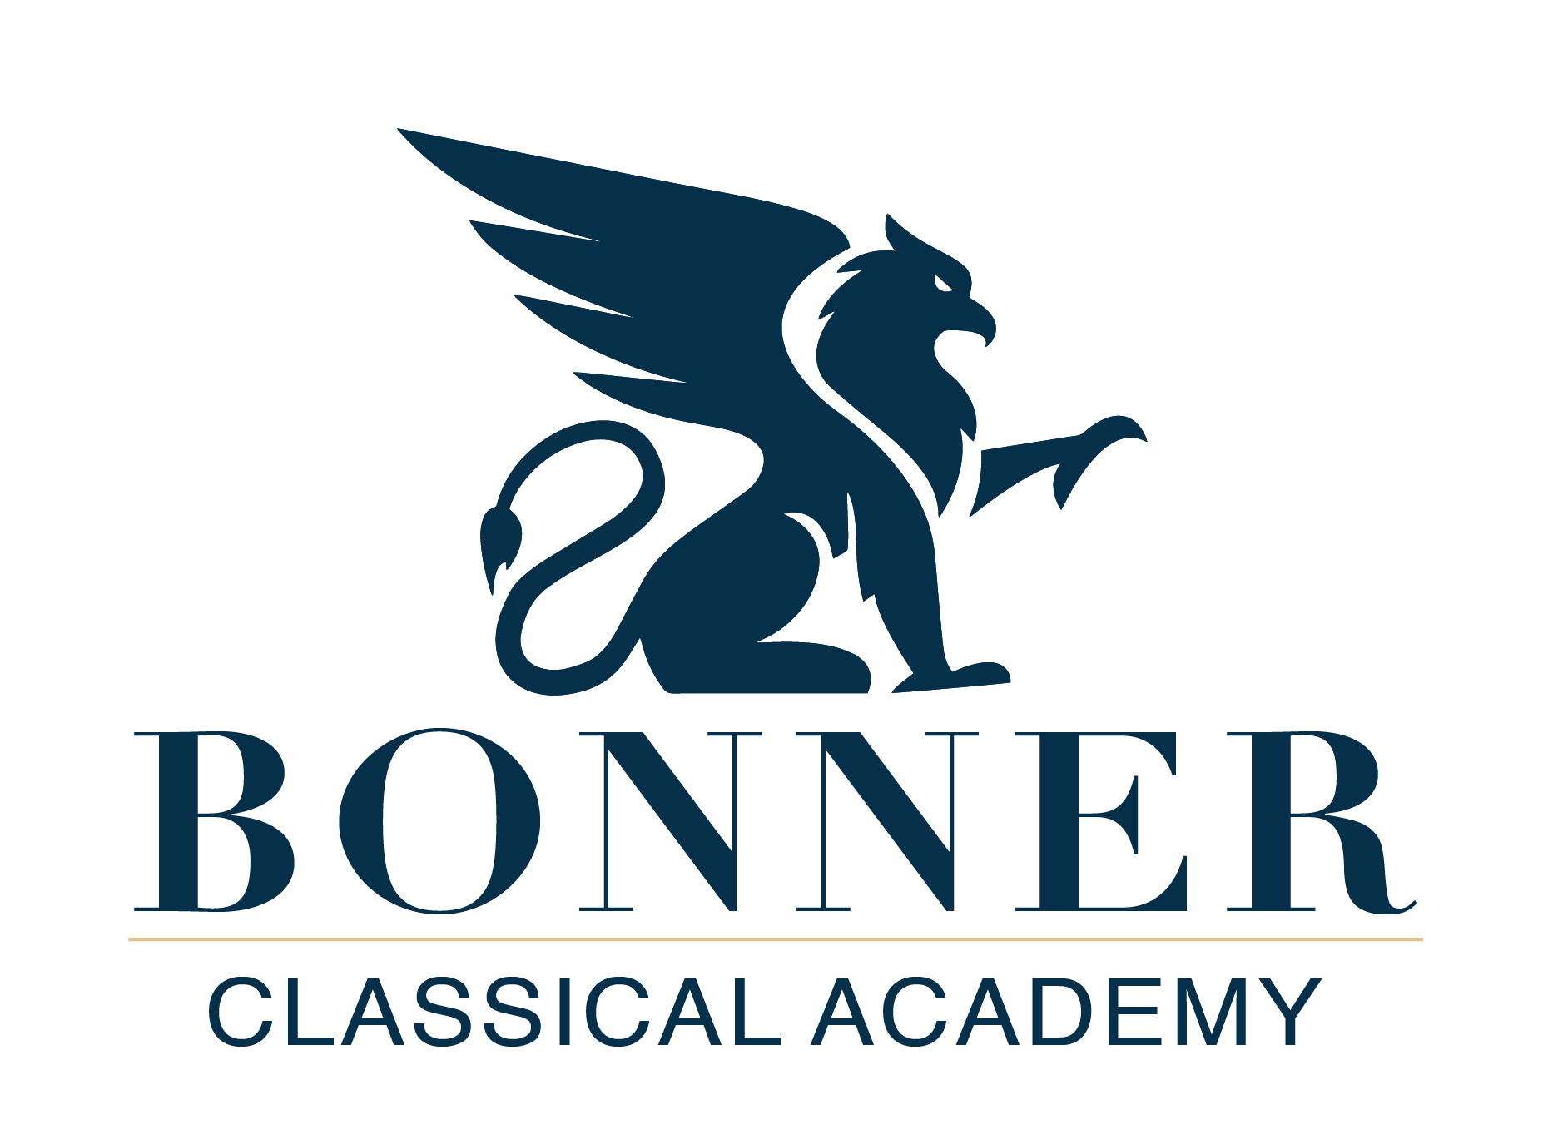

Email: [info@bonnerclassicalacademy.com](mailto:info@bonnerclassicalacademy.com)

Web: bonnerclassicalacademy.com

Bonner Classical Academy is now accepting applications for Kindergarten through 4th grade for the 2023-2024 school year. We will also accept 5th grade applications for families enrolling students in a lower grade.

Admissions will continue on a rolling basis until all seats are filled. In the summer, we will offer remaining open seats in upper elementary Fine Arts and Mechanical Arts for single class enrollment.

To apply to Bonner Classical Academy, please complete the following steps for each child:

* Request information and schedule optional meet and greet with Head of School.
  + Email [info@bonnerclassicalacademy.com](mailto:info@bonnerclassicalacademy.com) for scheduling.
* Fill out application form in FACTS: <https://bc-id.client.renweb.com/oa/?memberid=16978>. Within the application you will be asked to prepare the following materials:
  + Basic information about the student and household.
  + Behavior and learning questionnaire.
  + Request a confidential teacher questionnaire.
  + Submit previous school records and give consent for BCA to contact previous schools for records.
  + Request a pastoral letter of recommendation for the family; for non-church attending families, request a letter of recommendation from someone who is not a family member.
  + Kindergarten questionnaire, for Kindergarten applications only.
* $100 application fee (covers software and administrative costs).
* Read *An* *Introduction to Classical Education for Parents* by Dr. Perrin before the interview.
* Interview and Readiness Assessment: After all application materials are submitted, we will contact you to schedule a family interview and student readiness assessment. Parents and the children applying to enroll at the school will join Dr. Drexel and a member of the Admissions Committee for an in-person interview at the school office. For the first half of the meeting, we will meet together. For the second half of the meeting, Dr. Drexel will complete the interview with the parents while the Admissions Committee member completes the readiness assessment with the student(s). The readiness assessment is an opportunity informally to evaluate a students’ academic and developmental readiness for the grade he or she will enter. There is no need for students to prepare in advance.
* Following the interview, we will notify families of our admissions decision. For students who are accepted, we will extend a final packet for you to complete enrollment and reserve your child's seat in the classroom.